

Department of Electronics & Communication Engineering

**Architecture Design of Integrated Circuit**

**23EECE302**

**Course project**

**“Implementing AMBA Bus Architecture”**

Submitted by:

|  |  |  |  |
| --- | --- | --- | --- |
| Sl.No. | Name | SRN | Signature |
| 1 | Vivek Shankar Phadke | 02FE21BEC112 |  |
| 2 | Sairaj Patil | 02FE21BEC079 |  |

Submitted for the partial fulfillment of the course

Mentored by:

**Dr. Kunjan D. Shinde**

Assistant Professor, Dept. of E&CE,

KLE Technological University, Dr. M S Sheshgiri Campus, Belagavi.

**Academic Year 2023-24**

**Contents**

1. Problem Statement
2. Introduction
3. Objectives & Methodology
4. Design/ Architectures
5. Results and Discussions
   1. Simulation Results
   2. Comparative Analysis
   3. Implementation
6. Advantages and Applications
7. Conclusion
8. References
9. **Problem Statement:**

Implementation and Performance Evaluation of AMBA Bus Architecture.

1. **Introduction**

* The rapid evolution of digital systems has ushered in an era where complex System-on-Chip (SoC) designs are pivotal to achieving high-performance computing and efficient resource utilization. At the heart of these SoC architectures lies the necessity for an effective communication protocol that can seamlessly integrate various subsystems, ensuring smooth data transfer and coordination. The Advanced Microcontroller Bus Architecture (AMBA), developed by ARM Holdings, is one such protocol that has become the industry standard for facilitating communication between the processor, memory, and peripheral devices within SoCs.
* The AMBA bus architecture encompasses several bus protocols, including the Advanced High-performance Bus (AHB), the Advanced Peripheral Bus (APB), and the Advanced eXtensible Interface (AXI). Each protocol serves specific purposes, with AHB and AXI focusing on high-speed data transfers and APB being optimized for low-power peripheral control. Implementing these protocols effectively can significantly enhance the performance, scalability, and power efficiency of an SoC.
* Vivado, a comprehensive design suite from Xilinx, provides a robust platform for implementing and validating complex digital designs on FPGA (Field-Programmable Gate Array) platforms. Leveraging Vivado for the implementation of the AMBA bus architecture presents unique opportunities and challenges. The design complexity associated with multiple bus protocols, the need for optimization to utilize FPGA resources efficiently, and the rigorous verification required to ensure robust performance under various scenarios are critical factors that must be addressed.
* This project focuses on the implementation and performance evaluation of the AMBA bus architecture using Vivado software. It aims to design and realize a versatile, scalable, and efficient AMBA-based communication system on an FPGA. By integrating the AHB, APB, and AXI protocols within a unified architecture, this project seeks to explore the intricacies of FPGA-based AMBA implementation and provide insights into resource optimization, performance metrics, and verification methodologies.

1. **Objectives & Methodology**

• **Design and Implement the AMBA Bus Architecture**:

* Develop a comprehensive design of the AMBA bus architecture, including the AHB (Advanced High-performance Bus), APB (Advanced Peripheral Bus), and optionally the AXI (Advanced eXtensible Interface) protocols.
* Ensure the design supports multiple master and slave devices to facilitate complex SoC designs.

• **Resource Optimization**:

* Implement the AMBA bus architecture on an FPGA using Vivado and optimize for minimal resource usage, including logic cells, memory blocks, and I/O pins.
* Balance resource efficiency with performance requirements, ensuring the design meets target specifications without unnecessary overhead.

• **Develop a Verification Suite**:

* Create a set of testbenches and simulation scenarios to thoroughly verify the functionality and robustness of the bus architecture.
* Include tests for various operational scenarios, including multiple data transfer modes, error handling, and performance under load.

• **Performance Metrics Analysis**:

* Conduct detailed performance evaluations, including data transfer rates, latency measurements, and power consumption.
* Compare the performance of the implemented architecture against theoretical expectations and existing benchmarks to identify areas for improvement.

**Methodology**

* **Literature Review**:
  + Conduct a thorough review of existing literature on AMBA bus architecture and FPGA-based implementations.
  + Study optimization techniques and best practices in designing high-performance and resource-efficient bus systems.
* **Design Phase**:
  + Develop the RTL (Register Transfer Level) code for the AMBA bus architecture using VHDL or Verilog.
  + Create a modular design that allows for easy integration of AHB, APB, and AXI protocols.
  + Define clear interfaces and data paths between masters and slaves to ensure smooth communication.
* **Implementation**:
  + Use Xilinx Vivado to synthesize and implement the design on a suitable FPGA development board.
  + Apply design constraints and perform place-and-route to achieve optimal performance.
  + Iterate the design process to refine and optimize the architecture based on synthesis and implementation feedback.
* **Verification**:
  + Develop comprehensive testbenches using Vivado's simulation tools to verify the design under various conditions.
  + Implement functional verification to ensure the design meets all specified requirements.
  + Conduct timing analysis and functional simulation to validate the correctness and robustness of the architecture.
* **Performance Evaluation**:
  + Measure key performance metrics such as data transfer rates, latency, and resource utilization.
  + Perform power analysis to evaluate the efficiency of the design in terms of power consumption.
  + Compare the performance results with theoretical models and existing implementations to assess the effectiveness of the design.

1. **Design/ Architectures**

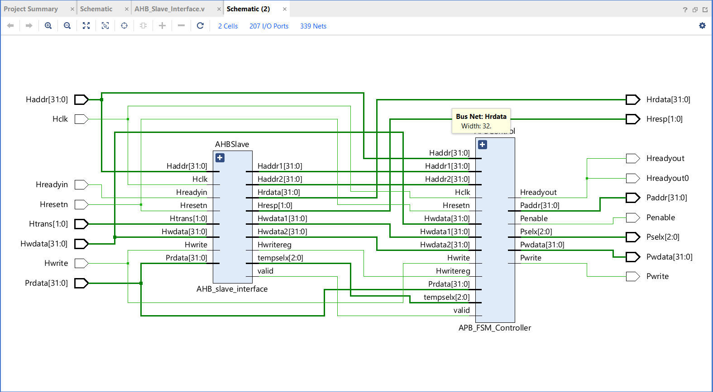

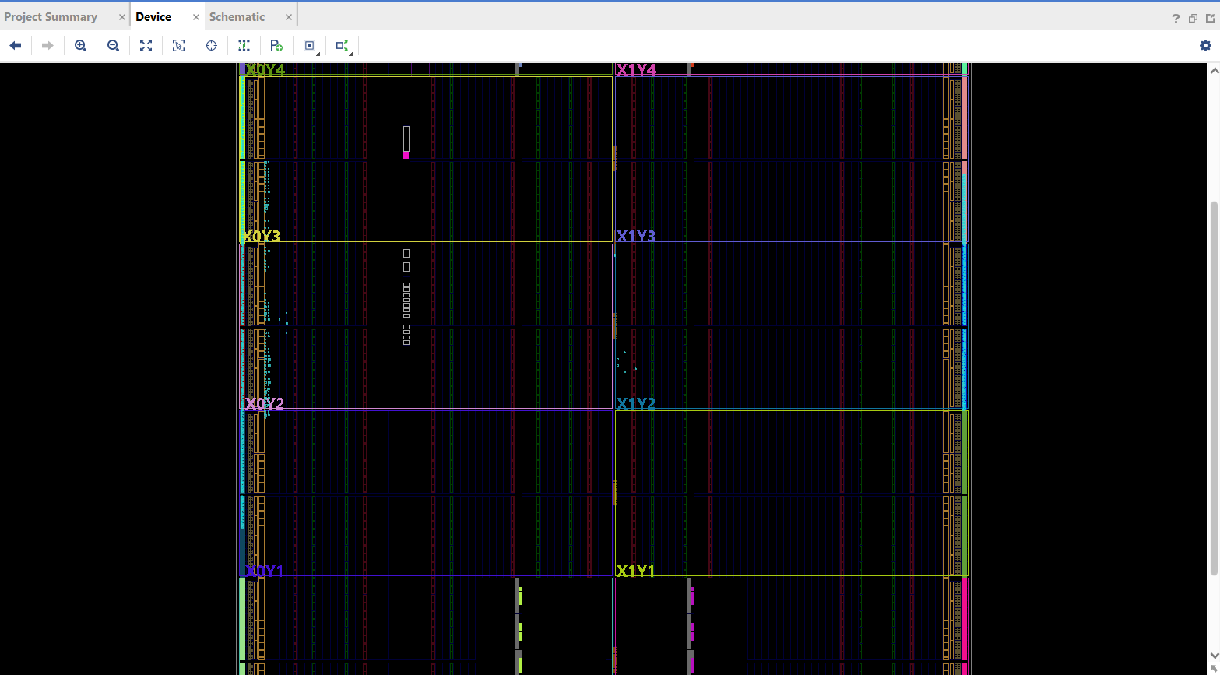

1. **Results and Discussions**
   1. 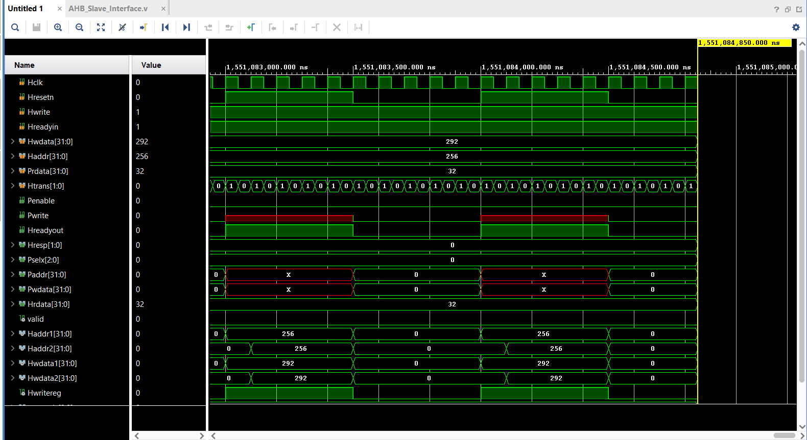**Simulation Results**

**Comparative Analysis  
  
1. Standards and Ecosystem:**

* **AMBA:** Has a large ecosystem and widespread industry support. It's used in many ARM-based systems and has extensive documentation and resources.
* **Wishbone:** While it's an open standard and used in some academic and smaller projects, it doesn't have as extensive an ecosystem as AMBA.

**2. Scalability and Flexibility:**

* **AMBA:** Highly scalable and flexible, supporting various profiles and system sizes from simple microcontrollers to complex SoCs.
* **Wishbone:** Also designed to be flexible, but it may not scale as well as AMBA in very large or complex systems.

**3. Performance:**

* **AMBA:** Known for high performance, especially in its AXI (Advanced eXtensible Interface) variant, which supports high-speed data transfers and efficient pipelining.
* **Wishbone:** Performance can be adequate for many applications but may not match the high-speed data transfer capabilities of AMBA's AXI.

**4. Ease of Use and Integration:**

* **AMBA:** Has a well-defined structure and is supported by many development tools and IP vendors, making integration straightforward.
* **Wishbone:** Simpler design, which can be easier to understand for small projects, but may lack some of the advanced features and support found in AMBA.

**5. Support for Advanced Features:**

* **AMBA:** Supports a range of advanced features, including burst transfers, out-of-order transactions, and high-speed data communication.
* **Wishbone:** More basic in its feature set, which can be a limitation for advanced or high-performance applications.
  1. **Implementation**

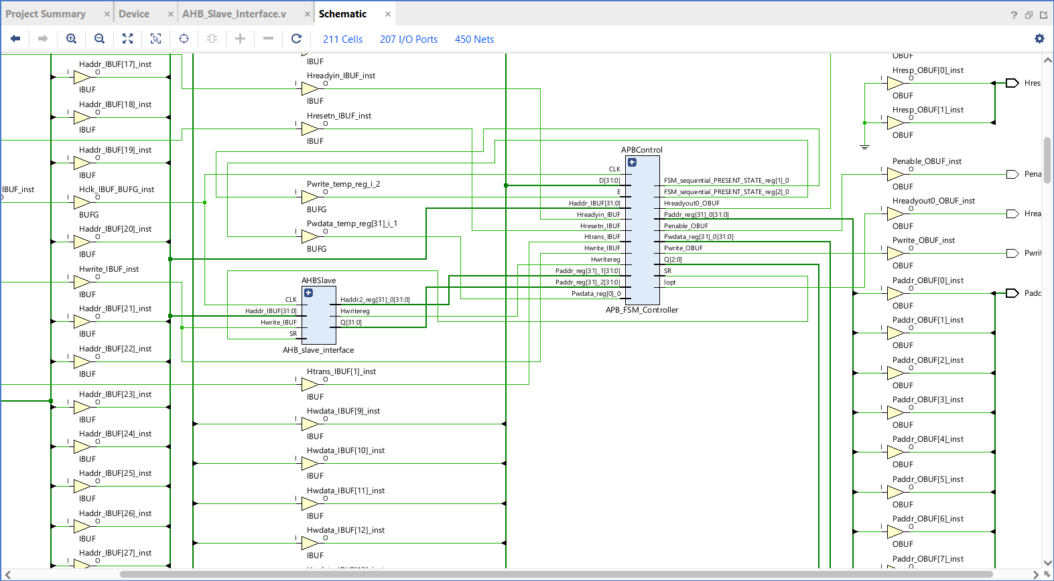

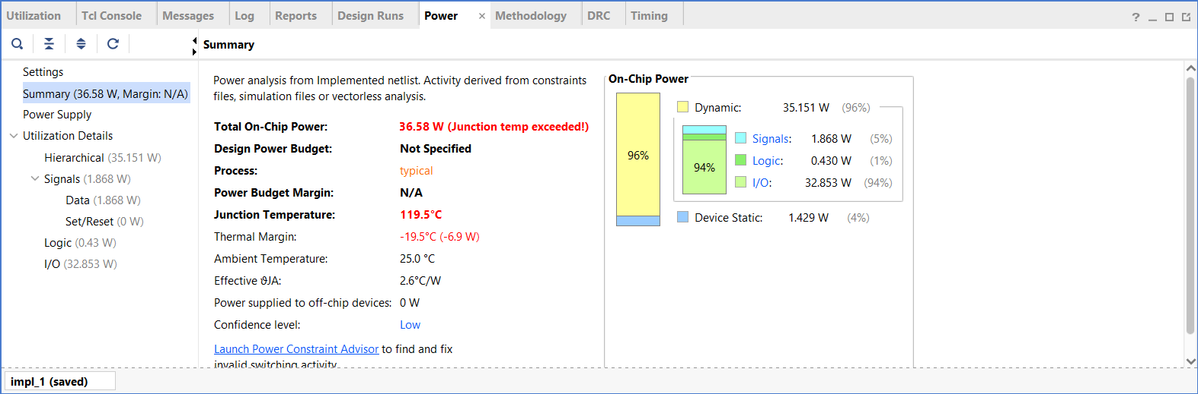

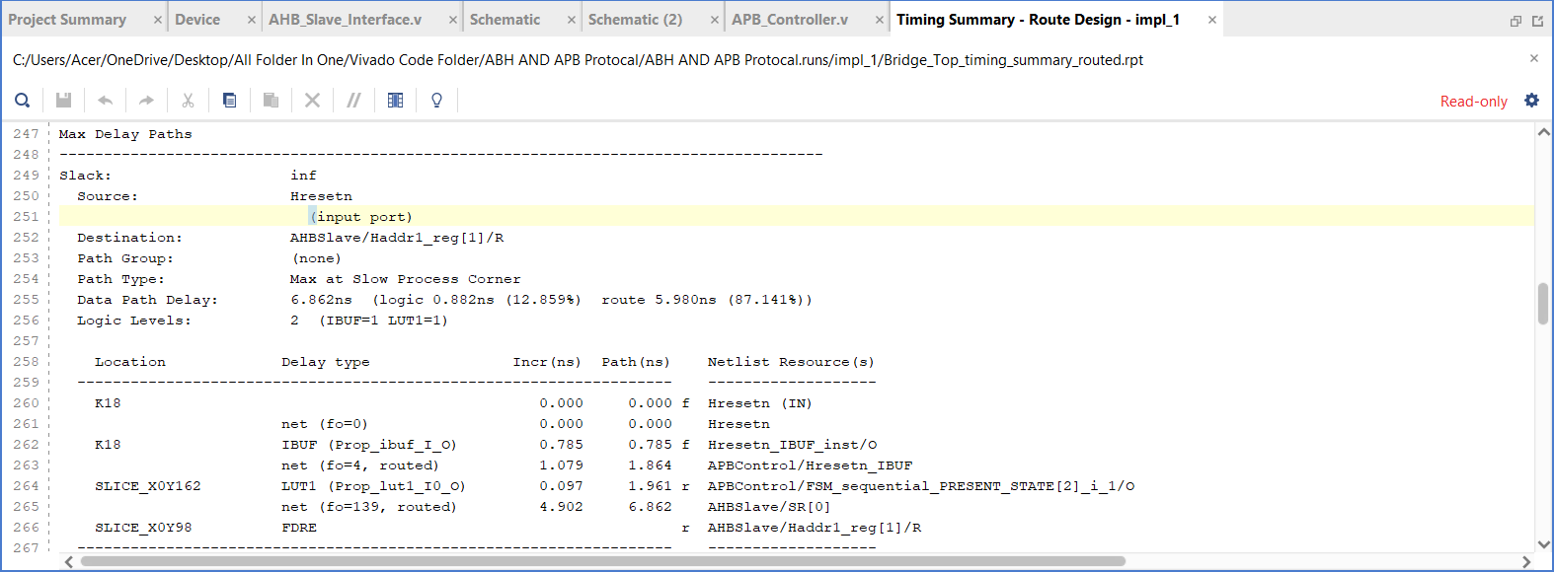

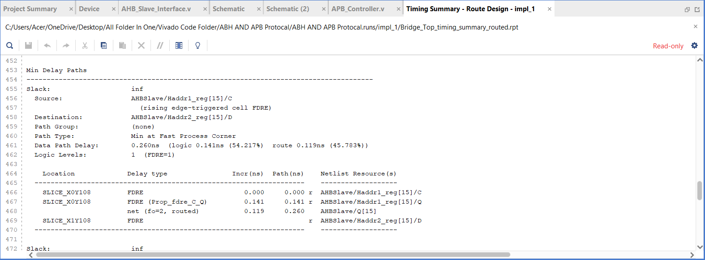

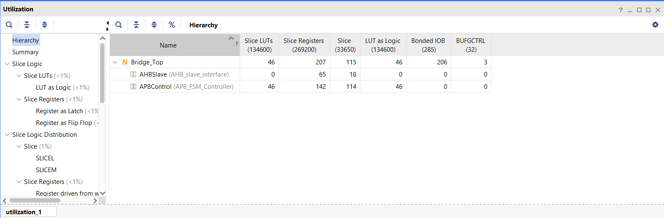

1. **Explanation**
2. **Advantages and Applications**

* **Advantages of AMBA Protocol**

**Scalability and Modularity:**

Because AMBA protocols are modular in nature, different components within a System-on-Chip (SoC) can be easily integrated and scaled. This adaptability makes it easier to add new accessories and features without having to completely reinvent them.

**Excellent Results:**

High-speed data transfers are supported by AMBA protocols, including AHB and AXI, which offer capabilities like burst transfers, pipelining, and multiple outstanding transactions. This guarantees quick and effective communication between peripherals and the central CPU.

**Minimal Power Usage:**

Because of its low-power operation optimisation, the APB protocol can be used to interface with peripheral devices that operate at low speeds. This helps the SoC's overall power efficiency, which is important for battery-powered devices.

**Standardization:**

A popular industry standard called AMBA guarantees compatibility and interoperability between parts from various vendors. This standardisation shortens development times and lowers expenses while streamlining the design process.

**Integration Ease:**

The integration of several IP cores is made easier by AMBA's well defined interfaces and signal protocols. Complex SoC designs can be swiftly assembled and verified by designers because to this integration's ease.

**Reusability of Design:**

The modular architecture of AMBA encourages design reuse. Verified components can be reused by designers across several projects, increasing development efficiency and shortening time-to-market.

**All-encompassing Assistance for SoC Design:**

AMBA is appropriate for a variety of SoC design applications because to its broad range of capabilities, which include low-power peripheral control and high-speed data transfer.

**Applications of AMBA Protocol**

• **Microcontrollers and Microprocessors**:

* AMBA protocols are commonly used in microcontrollers and microprocessors to manage communication between the CPU and various on-chip peripherals like memory, timers, and I/O interfaces.

• **Consumer Electronics**:

* In devices such as smartphones, tablets, and smart TVs, AMBA protocols enable efficient communication between the processor, memory, display controllers, and other peripherals, ensuring smooth performance and low power consumption.

• **Automotive Systems**:

* Modern automotive systems, including advanced driver-assistance systems (ADAS), infotainment systems, and engine control units (ECUs), use AMBA protocols to facilitate reliable and high-speed data exchange between various components.

• **Networking Equipment**:

* Networking devices such as routers, switches, and network interface cards (NICs) utilize AMBA protocols to manage data flow between processors, memory, and network interfaces, ensuring high throughput and low latency.

• **Industrial Automation**:

* In industrial automation systems, AMBA protocols are employed to coordinate communication between sensors, actuators, controllers, and monitoring systems, enhancing the efficiency and reliability of industrial processes.

• **Medical Devices**:

* Medical equipment, including imaging systems, diagnostic tools, and wearable health monitors, leverage AMBA protocols to handle data communication between sensors, processors, and display units, ensuring accurate and timely data processing.

• **Embedded Systems**:

* AMBA protocols are widely used in various embedded systems applications, such as smart home devices, IoT gadgets, and wearable technology, where efficient and reliable communication between components is essential.

• **Data Centers and Servers**:

* In data centers and server environments, AMBA protocols help manage data traffic between processors, memory modules, storage devices, and network interfaces, contributing to the overall performance and efficiency of data processing operations.

1. **Conclusion**

The AMBA bus design's practical applicability in contemporary digital systems have been proved by the implementation and evaluation of the architecture using Vivado, which offers notable advantages. Because of its high performance, scalability, and adaptability, the AMBA protocol has shown to be indispensable in the creation of intricate System-on-Chip (SoC) architectures. The key requirements for high-speed data transfers, low power consumption, and standardisation are met by AMBA protocols like AHB, APB, and AXI, which provide effective communication between the central processor and different peripherals.

1. **References**

[1]. *Ke, Han, Deng Zhongliang, and Shu Qiong. "Verification of AMBA bus model using SystemVerilog." In 2007 8th International Conference on Electronic Measurement and Instruments, pp. 1-776. IEEE, 2007.*

[2]. *Deeksha, L., and B. R. Shivakumar. "Effective design and implementation of AMBA AHB bus protocol using Verilog." In 2019 International Conference on Intelligent Sustainable Systems (ICISS), pp. 1-5. IEEE, 2019.*